Noah Magcalas

Jayden Cullen

CSCI 366

Assignment 8

November 19, 2023

Functionalities:

1. **Read** operations:
   1. Conditional (Noah)
      1. List all games owned by a user
      2. List all games of a genre
      3. List all reviews of a game
      4. List games in a price range
   2. Multi-table (Jayden)
      1. List games and their publishers’ name
   3. Data summary (Noah)
      1. Show the game with the most positive reviews
      2. Show the oldest user
      3. Show the newest game
2. **Write** operations:
   1. Insert (Jayden)
      1. Add a new user and track the games they own
      2. Add a publisher and their games
   2. Update (Jayden)
      1. Increase/decrease a game’s price
      2. Change a game’s description
      3. Change a user’s username/password
   3. Delete (Noah)
      1. Delete unsavory reviews
3. User interactions:
   1. Search for a game by title specified by user (Jayden)
   2. User can sort and read a game’s reviews based on positivity (Jayden)
   3. User can search for games from a specified publisher (Noah)

Programming Language:

**C#**

Entity Relationships:

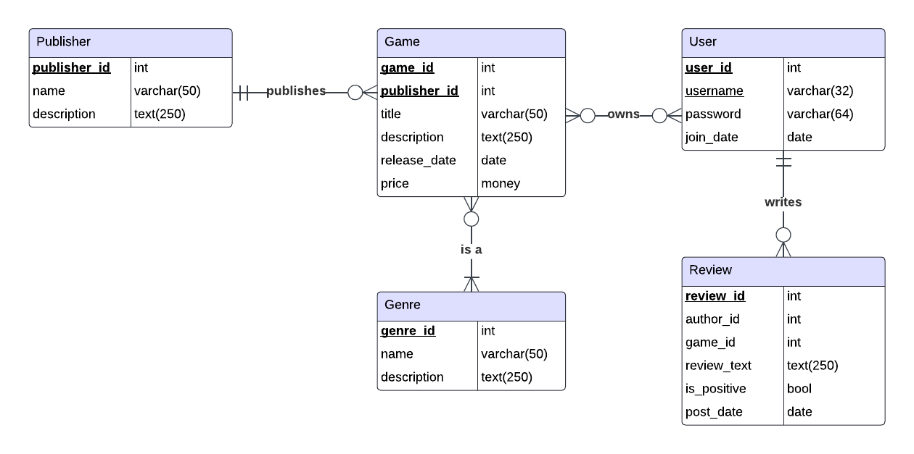

Class Design/Hierarchy:

